Exp no: 10 Develop vector auto regression model for multivariate time series data forecasting
Date: 15/4/25

Aim:
To develop and evaluate a Vector AutoRegression (VAR) model for multivariate time series forecasting using the Air Passenger dataset.
Objectives:
The key objectives are to preprocess and normalize the Air Passenger dataset along with an additional time series variable, ensure stationarity of the data using statistical methods, build and fit a suitable VAR model, forecast future values (e.g., next 12 months), and finally visualize and evaluate the accuracy of the forecasts.
Background/Scope:
Time series forecasting is widely used across industries to predict future trends based on past data. The Vector AutoRegression (VAR) model is a powerful multivariate tool that captures the linear interdependencies among multiple time series. This project uses the classic Air Passenger dataset, extended with a simulated variable (e.g., weather index) to create a multivariate time series. The focus is on building a robust VAR model that not only forecasts passenger numbers but also accounts for external factors influencing air travel.
Steps of Implementation:
Step 1: Load and Prepare the Multivariate Dataset
Import the Air Passenger dataset and create a second variable (e.g., Weather Index) to make it multivariate.

import pandas as pd
import numpy as np
# Load dataset
url = 'https://raw.githubusercontent.com/jbrownlee/Datasets/master/airline-passengers.csv'
df = pd.read_csv(url, parse_dates=['Month'], index_col='Month')
# Add a synthetic variable (Weather Index)
np.random.seed(0)
df['Weather_Index'] = df['Passengers'] + np.random.normal(0, 10, len(df))

Step 2: Normalize the Data
We normalize the data using MinMaxScaler to scale the values between 0 and 1. This is essential for neural networks to perform optimally.

import matplotlib.pyplot as plt
from sklearn.preprocessing import MinMaxScaler
# Normalize
scaler = MinMaxScaler()
scaled_data = scaler.fit_transform(df)
df_scaled = pd.DataFrame(scaled_data, columns=df.columns, index=df.index)
# Visualize
df.plot(figsize=(10, 5), title="Passengers vs Weather Index")
plt.show()

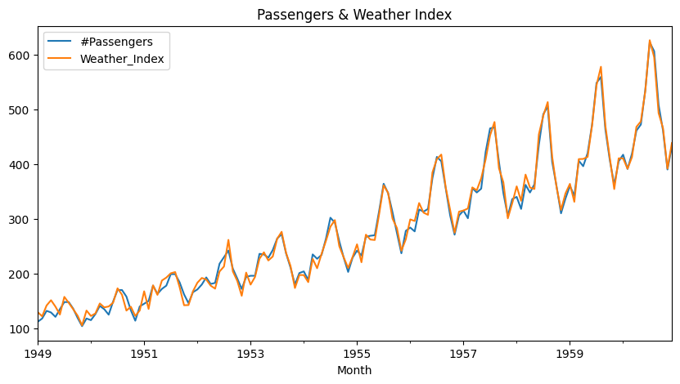

Step 3: Test for Stationarity and Difference the Data
Check for stationarity using the Augmented Dickey-Fuller test and apply differencing to make the data stationary.

from statsmodels.tsa.stattools import adfuller
def test_stationarity(timeseries):
result = adfuller(timeseries)
return result[1] # p-value
# Apply differencing
df_diff = df_scaled.diff().dropna()

Step 4: Fit the VAR Model
Use the VAR model from statsmodels to fit the differenced multivariate time series.

from statsmodels.tsa.api import VAR
# Fit VAR model
model = VAR(df_diff)
results = model.fit(maxlags=15, ic='aic')

Step 5: Forecast Future Values
Forecast future values using the trained VAR model by providing the required lagged values.

forecast_steps = 12
forecast = results.forecast(df_diff.values[-results.k_ar:], steps=forecast_steps)
forecast_df = pd.DataFrame(forecast, index=pd.date_range(start=df.index[-1], periods=forecast_steps+1, freq='MS')[1:], columns=df.columns)

Step 6: Reverse Transform and Visualize Forecast
Reverse the differencing and normalization to get forecasted values in the original scale, then visualize the results.

# Reverse differencing
last_values = df_scaled.iloc[-1]
forecast_reversed = forecast_df.cumsum() + last_values
# Inverse normalization
forecast_original = pd.DataFrame(scaler.inverse_transform(forecast_reversed),
columns=df.columns, index=forecast_reversed.index)
# Plot Forecast
plt.figure(figsize=(10, 5))
plt.plot(df.index, df['Passengers'], label='Original')
plt.plot(forecast_original.index, forecast_original['Passengers'], label='Forecast', linestyle='--')
plt.title("Air Passenger Forecast with VAR Model")
plt.xlabel("Date")
plt.ylabel("Passengers")
plt.legend()
plt.show()

Output:
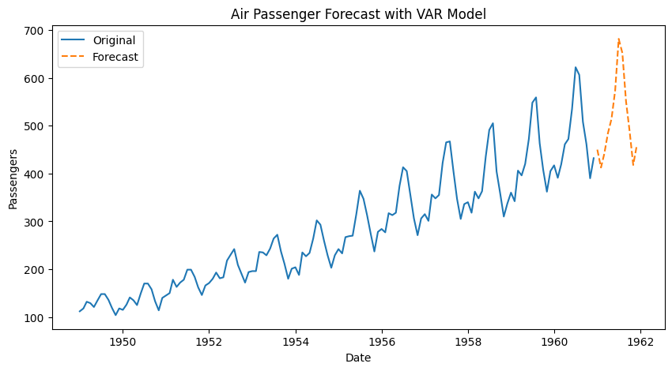

Result:
Vector auto regression model for multivariate time series data forecasting for air passenger dataset has been successfully implemented.

